Upgrading Field Data Manager Software

For Endress+Hauser employees with FDM already installed on their computer.
Create a Software Portal account. Go to:
https://software-products.endress.com/ui/private?redirect=softwareDownload/
Create an account if you do not already have one as your password will be needed later to activate the software ID.
Once the most recent software version has been pushed to your computer and the program is opened the program will open this window. Select the ‘Cancel’ button.
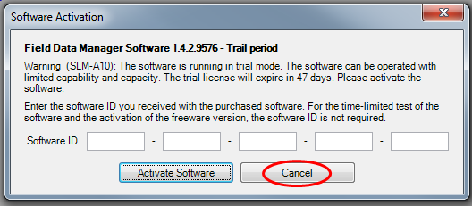

Then select the help menu and ADD. Help & License Information. This will open up the window below. Select the License information & Management tab.
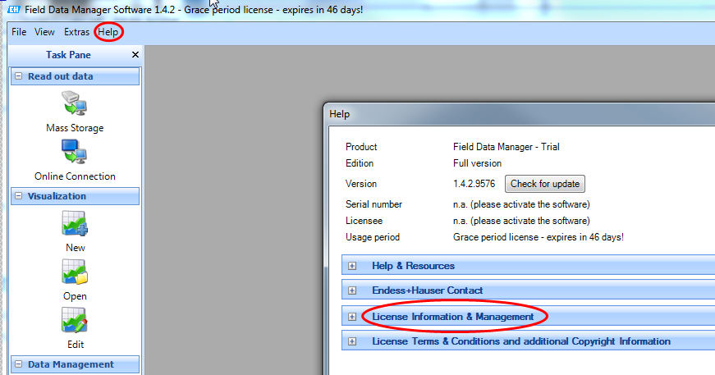

Then select the ‘Activate Software’ button
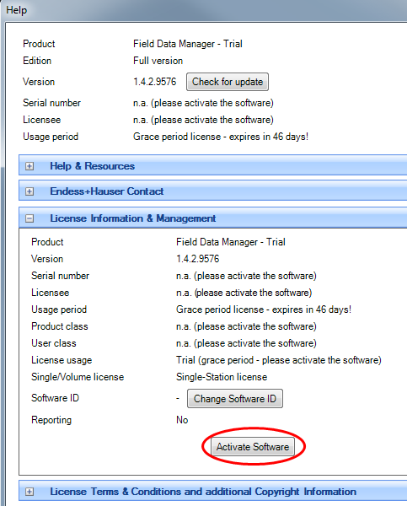

Enter the email address and password for the software portal and
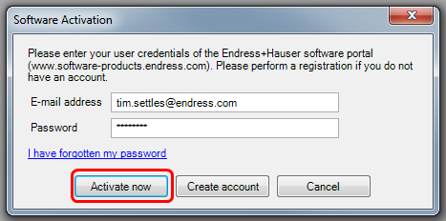

Once activated this window should be displayed.
