Please find below a step-by-step instruction on how to clean-up the missing profitability segment.

- Go to the incompletion log of an affected order via transaction VA02
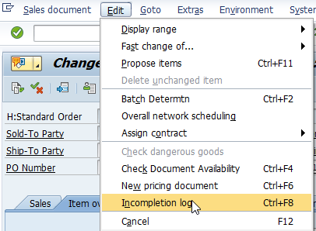

- Mark the line with the missing profitability segment and click on ‘Complete Data’
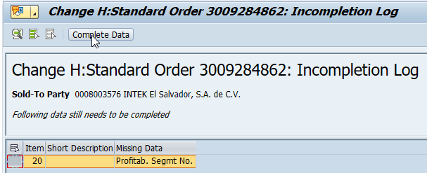

- Click the button ‘Profit. segment’
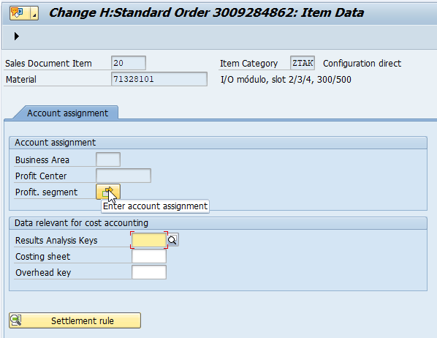

- Click on ‘Continue’
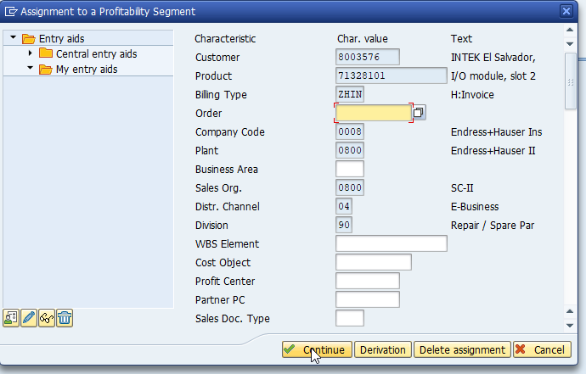
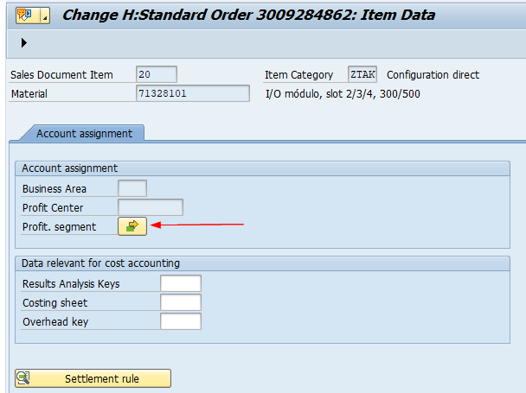
- The button ‘Profit. Segment’ turns green and the incompletion log will be cleared.
- Click the Save icon to save the Sales Order.

